**Bug Report 01**

**[The API of “Register” module is returning a "200 OK" response instead of "201 CREATED" for valid user registration]**

**Description**

**Environment**

OS: Windows 10 pro

Browser: Chrome Version 118.0.5993.70 (Official Build) (64-bit)

Postman

Application Server: jdbc:mysql <http://localhost:3306/final_project?createDatabaseIfNotExist=true&useSSL=false>

Build Date: 2023-10-10

**Pre-Conditions**

1. Valid credentials
2. Valid Endpoint

**Steps to reproduce**

1. Send API request to [Endpoint](http://localhost:8081/api/user/registerUser)
2. Set the method as POST
3. Pass all the valid data in password, phoneNo, profilePicture, role
4. Set the authentication as Admin token

**Expected Result**

The API should return the "201 CREATED" for successful user registration.

**Actual Result**

The API is returning a "200 OK" response instead of "201 CREATED" for valid user registration.

**Attached Document:**

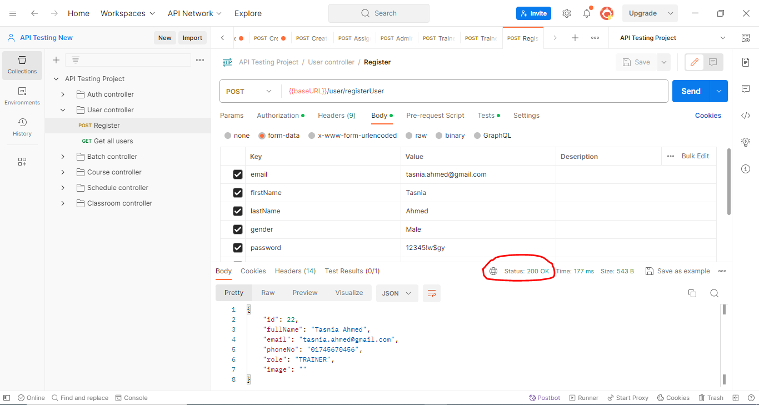

**Bug Report 02**

**[The API of the “Register” module returns the status code "400 Bad Request" for registering an already existing user instead of "409 Conflict".]**

**Description**

**Environment**

OS: Windows 10 pro

Browser: Chrome Version 118.0.5993.70 (Official Build) (64-bit)

Postman

Application Server: jdbc:mysql <http://localhost:3306/final_project?createDatabaseIfNotExist=true&useSSL=false>

Build Date: 2023-10-10

**Pre-Conditions**

1. Valid credentials
2. Valid Endpoint
3. The user has to be already registered

**Steps to reproduce**

1. Send API request to [Endpoint](http://localhost:8081/api/user/registerUser)
2. Set the method as POST
3. Pass all the same data of the already existing user
4. Set the authentication as Admin token

**Expected Result**

The response code should be a "409 Conflict" to indicate a conflict and proper message "User is already present in the database" for already existing users.

**Actual Result**

The API returns the status code "400 Bad Request" for registering an already existing user.

**Attached Document:**

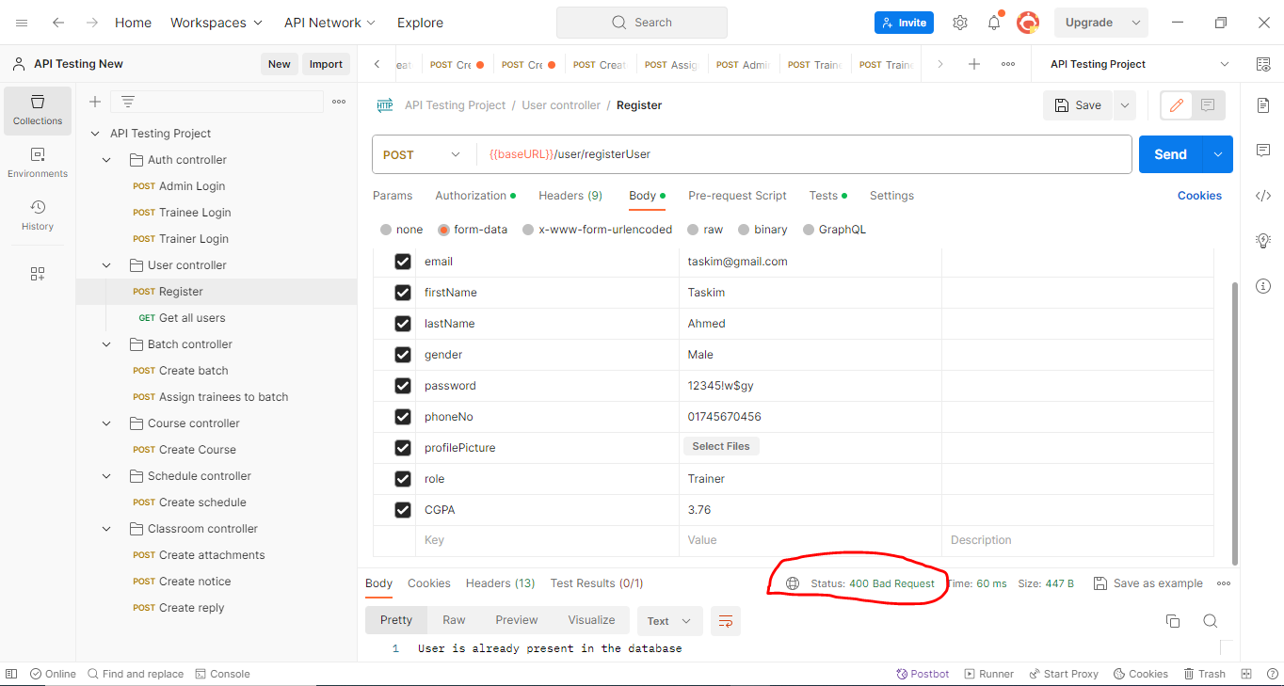

**Bug Report 03**

**[The API of “Register” module accepts the same contact numbers for different trainers and trainees]**

**Description**

**Environment**

OS: Windows 10 pro

Browser: Chrome Version 118.0.5993.70 (Official Build) (64-bit)

Postman

Application Server: jdbc:mysql <http://localhost:3306/final_project?createDatabaseIfNotExist=true&useSSL=false>

Build Date: 2023-10-10

**Pre-Conditions**

1. Valid credentials
2. Valid Endpoint

**Steps to reproduce**

1. Send API request to [Endpoint](http://localhost:8081/api/user/registerUser)
2. Set the method as POST
3. Pass all the valid and different data in password, profilePicture, role twice keeping the phoneNo same
4. Set the authentication as Admin token

**Actual Result**

The API accepts the same contact numbers for different trainers and trainees.

**Expected Result**

The API should accept unique contact numbers for registering trainers and trainees.

**Attached Document:**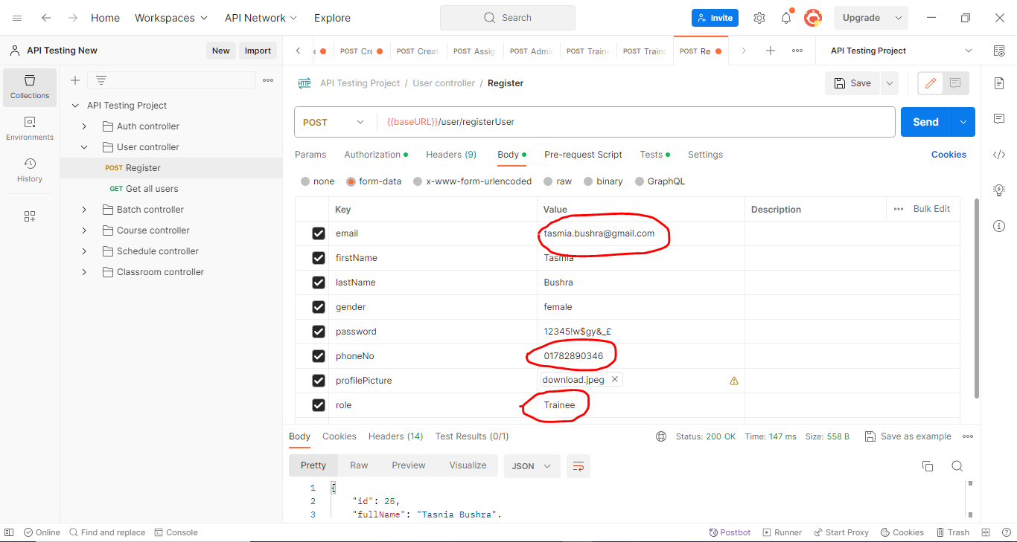

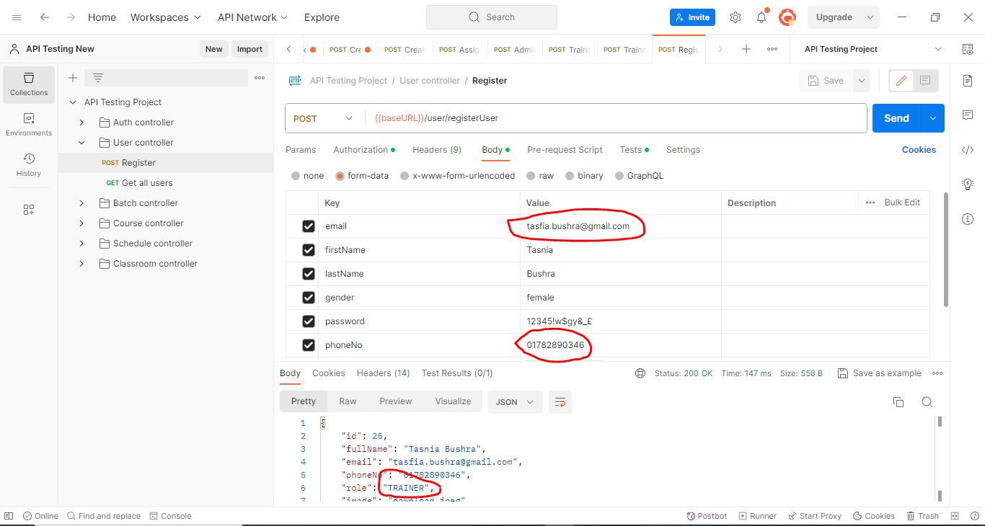

**Bug Report 04**

**[The API of “Register” module does not reject malformed data like wrong email, fullName, phoneNo format that are being accepted and registering an user]**

**Description**

**Environment**

OS: Windows 10 pro

Browser: Chrome Version 118.0.5993.70 (Official Build) (64-bit)

Postman

Application Server: jdbc:mysql <http://localhost:3306/final_project?createDatabaseIfNotExist=true&useSSL=false>

Build Date: 2023-10-10

**Pre-Conditions**

1. Valid credentials
2. Valid Endpoint

**Steps to reproduce**

1. Send API request to [Endpoint](http://localhost:8081/api/user/registerUser)
2. Set the method as POST
3. Pass all the long data in password, phoneNo, profilePicture, role
4. Set the authentication as Admin token

**Actual Result**

The API does not reject malformed data like wrong email, fullName, phoneNo format that are being accepted and registering an user.

**Expected Result**

The API should return "400 BAD REQUEST" for invalid input such as invalid email, fullName, phoneNo formats.

**Attached Document:**

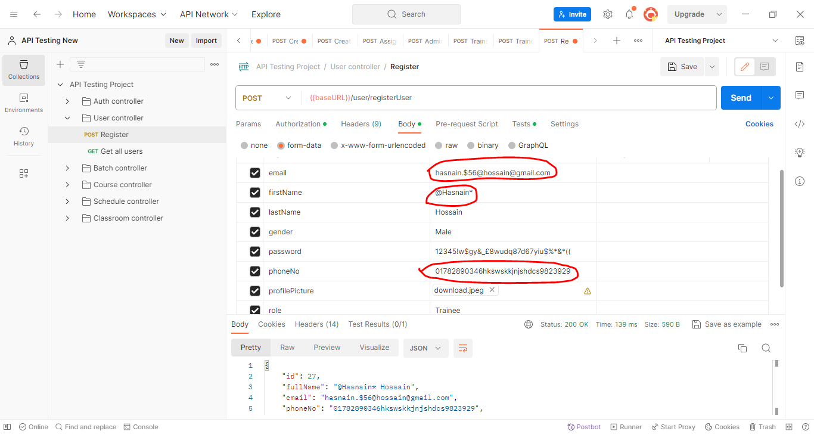

**Bug Report 05**

**[The API of “Register” module returns response code "403 Forbidden" for Authentication failure instead of "401 Unauthorized"]**

**Description**

**Environment**

OS: Windows 10 pro

Browser: Chrome Version 118.0.5993.70 (Official Build) (64-bit)

Postman

Application Server:jdbc:mysql <http://localhost:3306/final_project?createDatabaseIfNotExist=true&useSSL=false>

Build Date: 2023-10-18

**Pre-Conditions**

1. Valid credentials
2. Valid Endpoint

**Steps to reproduce**

1. Send API request to [Endpoint](http://localhost:8081/api/user/get-all-users)
2. Set the method as POST
3. Pass all the valid data in password, phoneNo, profilePicture, role
4. Set the authentication as Admin token

**Actual Result**

The response code is "403 Forbidden"

**Expected Result**

The API's response when provided with invalid Authentication like Authentication token other than Admin's token should be a "401 Unauthorized" status code.

**Attached Document:**

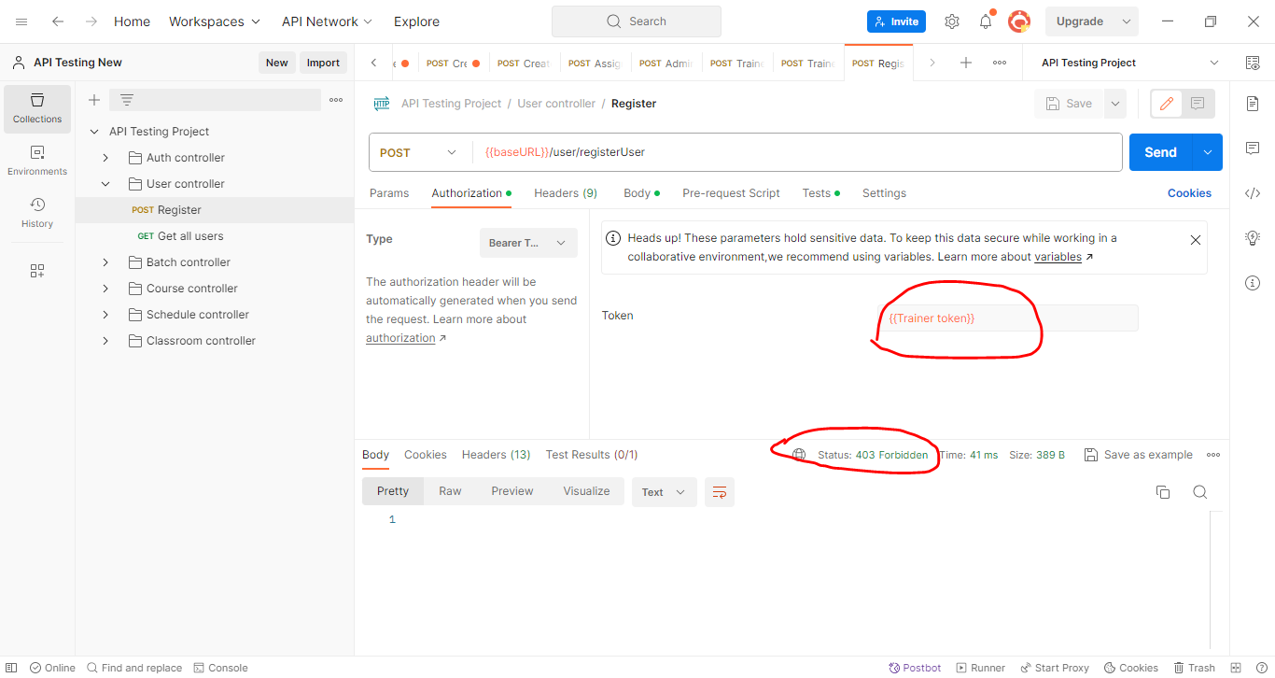

**Bug Report 06**

**[The response code of**  **“Get all users” module is "403 Forbidden" instead of "401 Unauthorized" in case of authentication]**

**Description**

**Environment**

OS: Windows 10 pro

Browser: Chrome Version 118.0.5993.70 (Official Build) (64-bit)

Postman

Application Server: jdbc:mysql <http://localhost:3306/final_project?createDatabaseIfNotExist=true&useSSL=false>

Build Date: 2023-10-10

**Pre-Conditions**

1. Valid credentials
2. Valid Endpoint

**Steps to reproduce**

1. Send API request to [Endpoint](http://localhost:8081/api/user/get-all-users)
2. Set the method as GET
3. Set the authentication as Admin token

**Actual Result**

The response code is "403 Forbidden"

**Expected Result**

The API's response when provided with invalid Authentication like Authentication token other than Admin's token should be a "401 Unauthorized" status code.

**Attached Document:**

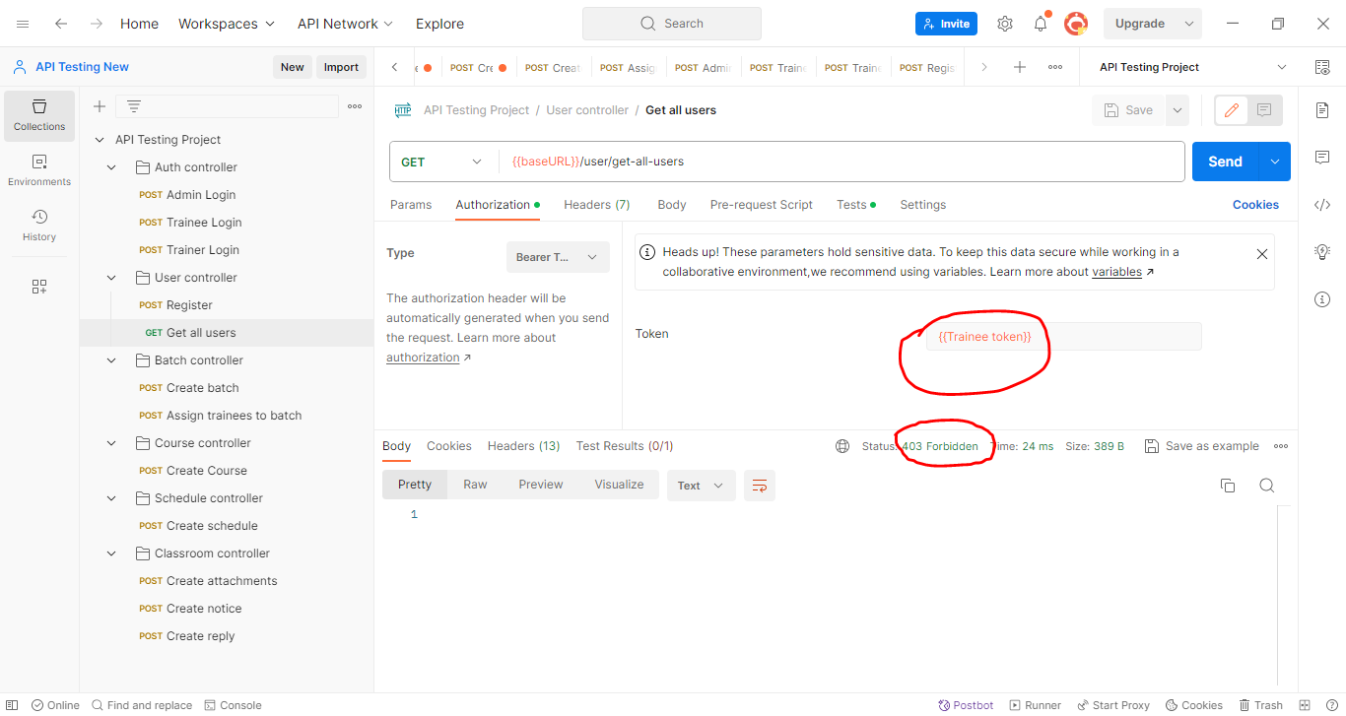

**Bug Report 07**

**[The response code of “Create a batch” is "403 Forbidden" instead of "401 Unauthorized" to create a new batch with Trainers and Trainees token]**

**Description**

**Environment**

OS: Windows 10 pro

Browser: Chrome Version 118.0.5993.70 (Official Build) (64-bit)

Postman

Application Server: jdbc:mysql <http://localhost:3306/final_project?createDatabaseIfNotExist=true&useSSL=false>

Build Date: 2023-10-10

**Pre-Conditions**

1. Valid credentials
2. Valid Endpoint

**Steps to reproduce**

1. Send API request to [Endpoint](http://localhost:8081/api/user/registerUser)
2. Set the method as POST
3. Pass all the valid data in batchName, startTime, endTime
4. Set the authentication as Admin token

**Actual Result**

The response code is "403 Forbidden" to create a new batch with Trainers and Trainees token.

**Expected Result**

The API's response should be a "401 Unauthorized" status code for Trainers and Trainees token.

**Attached Document:**

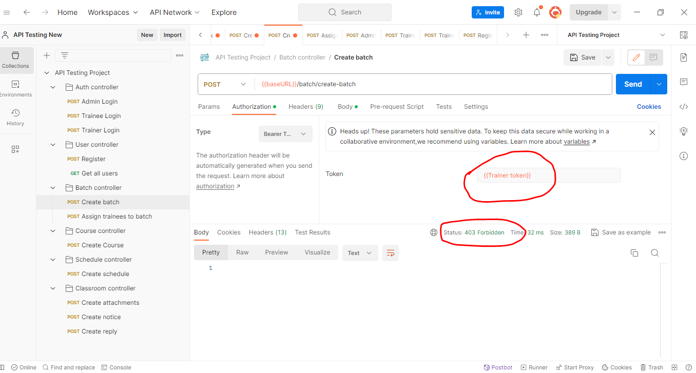

**Bug Report 08**

**[The API of “Assign trainees to batch” module returns a "200 OK" response by assigning one trainee to multiple batches]**

**Description**

**Environment**

OS: Windows 10 pro

Browser: Chrome Version 118.0.5993.70 (Official Build) (64-bit)

Postman

Application Server: jdbc:mysql <http://localhost:3306/final_project?createDatabaseIfNotExist=true&useSSL=false>

Build Date: 2023-10-10

**Pre-Conditions**

1. Valid credentials
2. Valid Endpoint

**Steps to reproduce**

1. Send API request to [Endpoint](http://localhost:8081/api/classroom/assign-trainees-to-batch)
2. Set the method as POST
3. Pass same traineeEmail and different batchName multiple times
4. Set the method as POST

**Actual Result**

The API is returning a "200 OK" response by assigning one trainee to multiple batches.

**Expected Result**

One trainee should be added in one batch.

**Attached Document:**

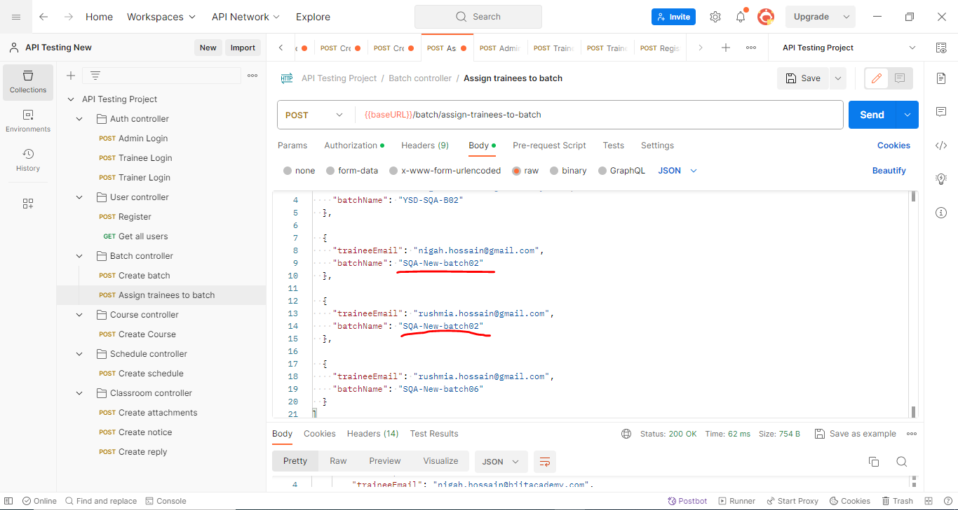

**Bug Report 09**

**[The API of “Create a course” module returns id as a null value]**

**Description**

**Environment**

OS: Windows 10 pro

Browser: Chrome Version 118.0.5993.70 (Official Build) (64-bit)

Postman

Application Server: jdbc:mysql <http://localhost:3306/final_project?createDatabaseIfNotExist=true&useSSL=false>

Build Date: 2023-10-19

**Pre-Conditions**

1. Valid credentials
2. Valid Endpoint

**Steps to reproduce**

1. Send API request to [Endpoint](http://localhost:8081/api/classroom/assign-trainees-to-batch)
2. Set the method as POST
3. Pass all the valid data in batchName, startTime, endTime
4. Set the authentication as Admin token

**Actual Result**

The id is returned as a null value.

**Expected Result**

The response body should contain expected fields and data in Create a course.

**Attached Document:**

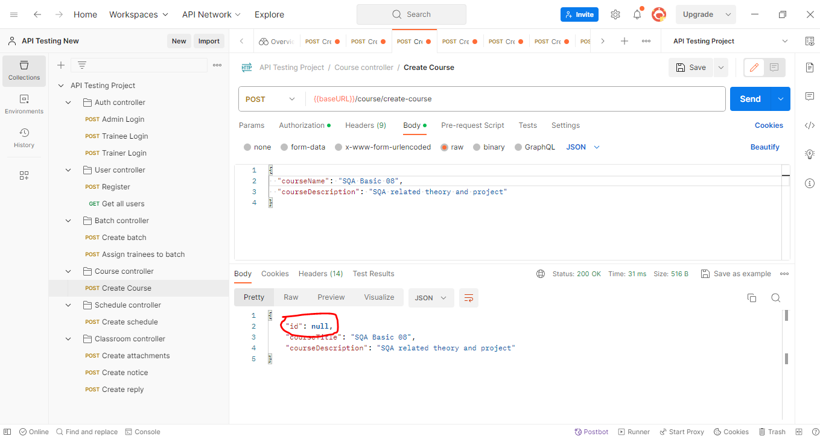

**Bug Report 10**

**[The API of “Create a schedule” module responds id as a null value]**

**Description**

**Environment**

OS: Windows 10 pro

Browser: Chrome Version 118.0.5993.70 (Official Build) (64-bit)

Postman

Application Server: jdbc:mysql <http://localhost:3306/final_project?createDatabaseIfNotExist=true&useSSL=false>

Build Date: 2023-10-19

**Pre-Conditions**

1. Valid credentials
2. Valid Endpoint

**Steps to reproduce**

1. Send API request to [Endpoint](http://localhost:8081/api/schedules/create-schedule)
2. Set the method as POST
3. Pass all the valid data in scheduleName, startTime, endTime, courseTitle, batchName, trainerEmail
4. Set the authentication as Admin token

**Actual Result**

The id returns a null value.

**Expected Result**

The response body should contain expected fields and data in Create a schedule.

**Attached Document:**

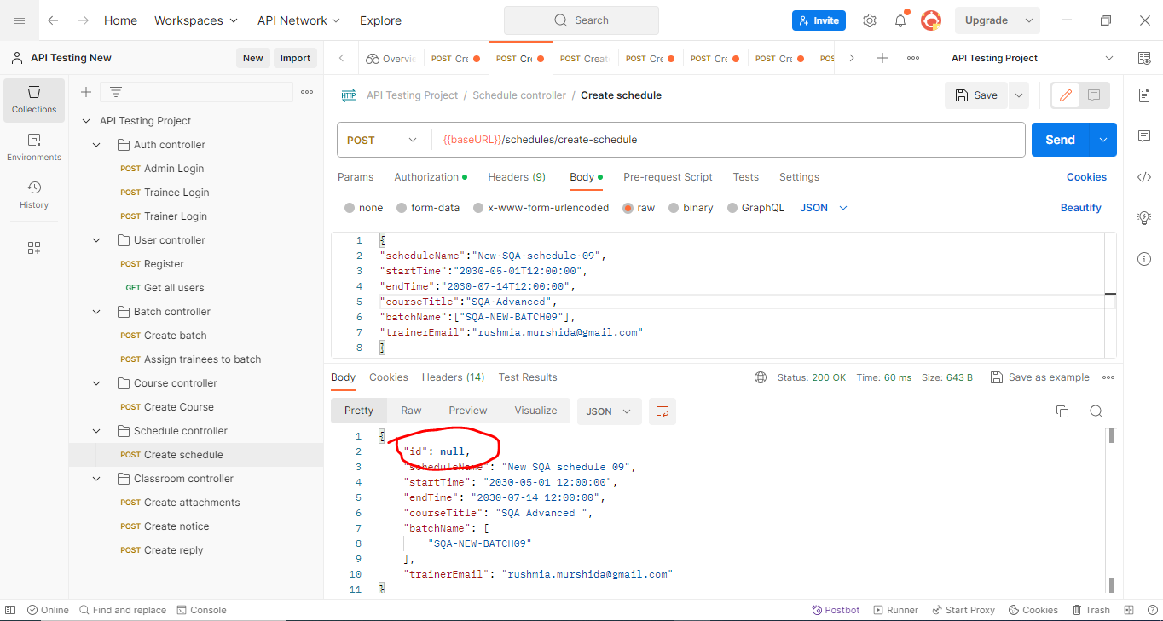

**Bug Report 11**

**[The API of “Create a schedule” module returns "No trainer by this name" for invalid trainer email and "400 Bad Request" for any non existing data]**

**Description**

**Environment**

OS: Windows 10 pro

Browser: Chrome Version 118.0.5993.70 (Official Build) (64-bit)

Postman

Application Server: jdbc:mysql <http://localhost:3306/final_project?createDatabaseIfNotExist=true&useSSL=false>

Build Date: 2023-10-10

**Pre-Condition**

1. Valid credentials
2. Valid Endpoint

**Steps to reproduce**

1. Send API request to [Endpoint](http://localhost:8081/api/course/create-course)
2. Set the method as POST
3. Pass all the valid data in scheduleName, startTime, endTime, courseTitle, batchName, trainerEmail
4. Set the authentication as Admin token

**Actual Result**

The API returns "No trainer by this name" for invalid trainer email and "400 Bad Request" for any non existing data.

**Expected Result**

The API should return a "404 Not Found" response when attempting to access a non-existent resource such as trainerEmail and a proper message.

**Attached Document:**

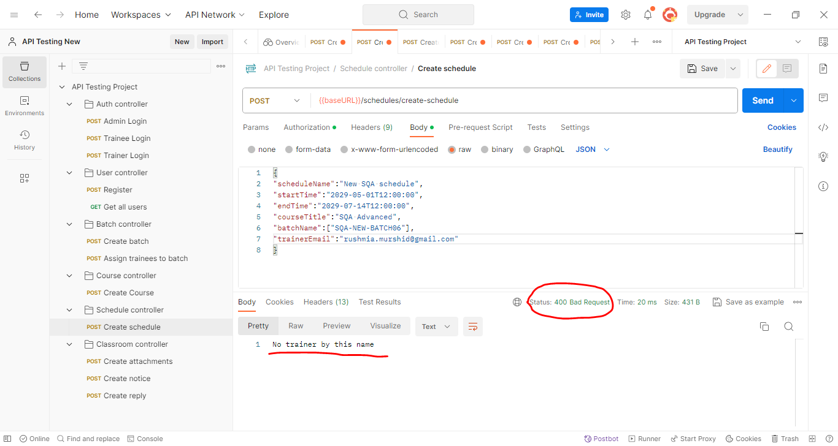

**Bug Report 12**

**[The API returns "No classroom to post notice" for invalid classroomId and "400 Bad Request" for any non existing data in Create post]**

**Description**

*Environment *

OS: Windows 10 pro

Browser: Chrome Version 118.0.5993.70 (Official Build) (64-bit)

Postman

Application Server: jdbc:mysql <http://localhost:3306/final_project?createDatabaseIfNotExist=true&useSSL=false>

Build Date: 2023-10-19

**Pre-Conditions**

1. Valid credentials
2. Valid Endpoint

**Steps to reproduce**

1. Send API request to [Endpoint](http://localhost:8081/api/classroom/create-notice)
2. Set the method as POST
3. Pass all the valid data in form-data format for message, fileName, trainerEmail, classroomId
4. Set the authentication as Trainer token

**Actual Result**

API returns "No classroom to post notice" for invalid trainer email and "400 Bad Request" for any non existing data in Create notice.

**Expected Result**

The API should return a "404 Not Found" response while attempting to access a non-existent resource and a proper message.

**Attached Document:**

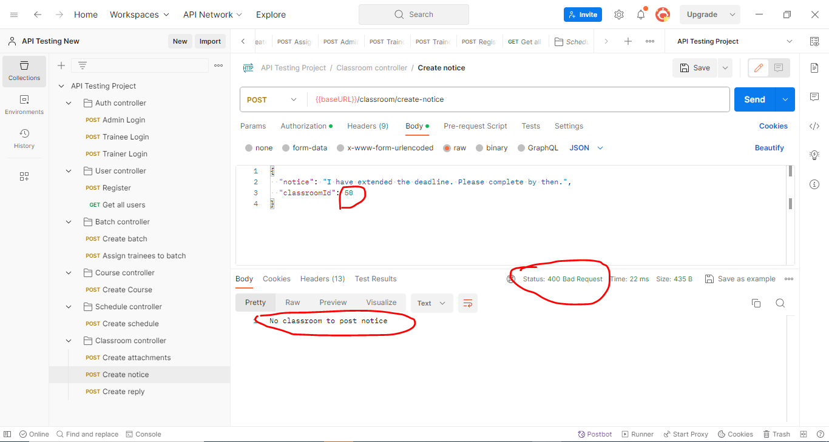

**Bug Report 13**

**[The API of “Create attachments” module returns wrong trainerEmail]**

**Description**

**Environment**

OS: Windows 10 pro

Browser: Chrome Version 118.0.5993.70 (Official Build) (64-bit)

Postman

Application Server: jdbc:mysql <http://localhost:3306/final_project?createDatabaseIfNotExist=true&useSSL=false>

Build Date: 2023-10-10

**Pre-Conditions**

1. Valid credentials
2. Valid Endpoint

**Steps to reproduce**

1. Send API request to [Endpoint](http://localhost:8081/api/classroom/create-attachments)
2. Set the method as GET
3. Pass all the valid data in form-data format for message, fileName, trainerEmail, classroomId
4. Set the authentication as Trainer token

**Actual Result**

The API returns the wrong trainerEmail in the Create post in the classroom.

**Expected Result**

The API response should contain expected fields and correct data in the Create post in the classroom.

**Attached Document:**

